Monte Carlo Plan Guide for Student Volunteers.

**Table of content**

+ Contact list

+ Monte Carlo 2022 - Chair & Sub-Committee Roles

+ Monte Carlo Planning Timeline

+ Monte Carlo Event Time Schedule

+ Training/ Duty division

* Explanation of each team.
* Number of Volunteers for each committee

+ Operations

* What to expect
* Rain Plan
* Gambling Entertainment

+ Building/Event layout

+ Campus safety and other contacts.

**Contact list**

Contacts of Committee Members

***CMA***

**Contacts of Colleen**

Colleen McInerney - (708) 559-3471 – colleen.mcinerney@kzoo.edu

**Contacts of Nolan**

Nolan Trinh – (269)-220-9642 – nghia.trinh20@kzoo.edu

**Monte Carlo 2022 - Chair & Sub-Committee Roles**

**Committee Chair:** this individual will be the first line of communication between OSA and sub-committee leaders. They will be tasked with leading meetings and providing guidance and assistance for sub-committees.

* Nghia (Nolan) Trinh

**Secretary**: this person will be responsible for keeping meeting minutes of the Monte Carlo Committee meetings and sending those minutes to OSA ([colleen.mcinerney@kzoo.edu](mailto:colleen.mcinerney@kzoo.edu)). This person will potentially have oversight and maintenance of the MC budget.

* Nghia (Nolan) Trinh

**Sub-Committees:**

**Food:** this committee will be responsible for picking out, budgeting for, and ordering the food served at Monte Carlo. This committee will work with K’s Catering Services and potential off-campus food vendors to order food for the event. This committee may work closely with other committees, such as decorations, to determine where and when food with be served at Monte Carlo.

* Lead person: Claudia Escalante
  + Zhi Tian Wee

**Entertainment**: this committee will be responsible for imagining, budgeting for, and determining what entertainment will take place at Monte Carlo. Essentially answering the question: what are attendees doing when they come to Monte Carlo? This group may work closely with groups outside of just the MC planning committee (for example, student organizations) to lay out the timeline of events/activities/performances/etc. for the day of the event.

* Lead person: Celia A. Kuch
  + Samuel R. File
  + Joanna Nonato
  + Cate VanSchaik
  + Brett Manski

**Decorations**: this committee will be highly creative in nature. The decorations committee will listen to the feedback of the larger group + campus body to determine a theme for Monte Carlo, and create the ambiance that supports that for the event. This committee will be responsible for budgeting for decorations, t-shirts, etc.

* Lead person: Kennedy Christl
  + Aarzoo Qureshi
  + Zaydee A. Menchaca

**Prizes**: this committee will work to determine what attendees and those who play the casino-based games receive. Budgeting will be important, as well as creativity, as there is room to offer a broad range of prizes to folks at Monte Carlo.

* Lead person: Lizzy Rottenberk
  + Charlie Hoag

**Volunteer Recruitment & Advertising**: this committee will have creative freedom in the way we advertise Monte Carlo to the campus community at K. In addition, this committee will focus efforts on the recruitment of volunteers necessary in executing this large campus event!

* Lead person: Yoichi Haga
  + Charlie Hoag
  + Cate VanSchaik

**Monte Carlo Committee Timeline**

Spring Week Four (4/18)

* Volunteer Form Due on Friday week four.

Spring Week Five (4/25)

* Finalize the Volunteer list

Spring Week Six (5/2):

* Discuss safety and security/ develop plan

+ Invite Tim young to meeting

* Email out to campus discussing how Monte Carlo is going to work (following meeting)

+Include check-in details, safety details. Consequences, etc.

+Include link to Monte Carlo website hosted on OSA website.

Spring Week Seven (5/9):

* Confirm volunteer roles
* Confirm committee roles
* Invite Dean Smith to the meeting

Spring Week Eight (5/16):

* Reminder email to campus about how Monte Carlo will work (with any additional changes).

**Monte Carlo Event Time Schedule**

***TBA***

|  |  |
| --- | --- |
| Friday, May 20th | |
| 5:00PM – 7:00PM  Lower Atrium Hicks | Rearrange all chairs and tables  All volunteers. |
|  | Preparation of the Decorations |
|  | Preparation of the Entertainment |
|  |  |

|  |  |
| --- | --- |
| Saturday, May 21st | |
| 2:00PM – 3:00PM  Lower Atrium Hicks | Student meet up  All volunteers and committee planners |
| 3:00PM – 7:00PM  Hicks | TjohnE Production Setup |
| 7:30PM – 11:30PM  Indoor Hicks | Pro Dealers |
| 7:30PM - 8:30PM  Volunteer Lounge | Student training |

**Training/ Duty Division**

Decorations:

-The Decorations division will take over the inside decorations of Hicks and the decorations on the Quad.

Entertainment:

-The Entertainment division will manage the tents on the Quad

-The Entertainment will also take care of assisting the musical events on stage.

Foods:

-We will have the two vendors coming to campus: Eli’s Churros & Olly’s Donut’s (appeared at KFest 2021).

Volunteer:

-This committee will take care of coordination, crowd control, and instructional guide to all students.

Prizes:

-The Prizes division will manage the awards and prizes that are given out. Students who are awarded big prizes may not

|  |  |
| --- | --- |
| Prizes | 14 |
| Entertainment (gambling tables & outside games) | 48 |
| Food | 4 |
| Decorations | 15-30 |
| Check-in | 13 |
| Security | 15 |

**Operations**

What to expect?

- There will be around 1000-1200 guests to the event

- Guests may bounce around going to the outdoor events or indoor events.

- There may be guests from outside of school that are coming to the event.

Rain Plan

-All aspects of entertainment on the stage will be relocated to the chapel.

-Notice the guests in advance to bring an umbrella .

Gambling

-Staff/ Faculty will take on the main duty of dealing the entertainment.

-The gambling entertainment: 19 tables: 10 Black Jack, 5 poker, 2 roulette, 2 tables of craps.

**Building/ Event Layout**















**The Quad:**

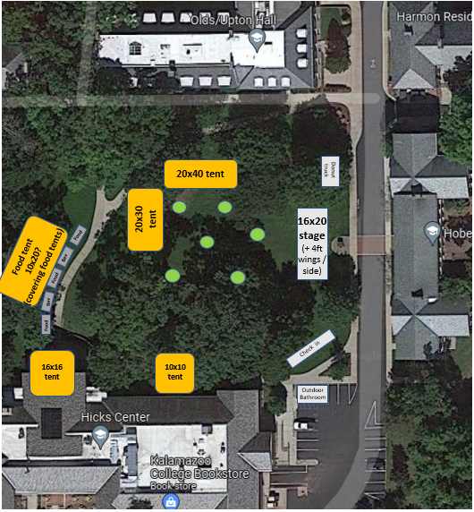

**Campus safety and Volunteer contact list**

**-TBA**